In order to set up online donations I will require the following information. Please note all of the information must be provided in order to complete set-up. We are not able to set up fundraising for events unless the charity is officially registered in Canada or the US.
- Official Charity Name
- Charity Logo (please send as jpeg)
- Charity Registration Number
- Email address for the individual to receive Charity Director Access (Multiple individuals can receive Charity Director Access, each individual must have or sign-up for a Running Room Account)
- Charity Mailing Address
- A brief description of your charity
- Email address for Charity contact (to receive donation/receipt notifications)
- Would you like Official or Temporary Tax Receipts issued by the Running Room?
  - Temporary Tax Receipts: Confirms that the donation was successful and informs the donor that an Official Tax Receipt will be issued by your charity at a later date. Please note: The donor MUST be issued an Official Tax Receipt for the full amount of the donation which includes the 6.5% processing fee.
If you are choosing Temporary Tax Receipts, please complete the following:
I, (insert name), understand that the donor must be issued an Official Tax Receipt for the full amount of the donation, including the 6.5% processing fee.
  - Official Tax Receipts: Completed by Running Room on behalf of the charity. The following information is required to set-up Official Tax Receipts.
    - The full name and position of an individual with signing authority at the charity.
    - A PDF signature of the above individual.
A block of receipt numbers for the Official Tax Receipts. (e.g. 1-1000). Please note: The Tax Receipts numbers cannot be altered once they are entered. We suggest a minimum of 500 per site.
The Running Room can issue two types of receipts - Temporary or Official Tax Receipts.
Temporary Tax Receipts: Confirms that the donation was successful and informs the donor that an Official Tax Receipt will be issued by your charity (ie. The War Amps) at a later date. Please note: The donor MUST be issued an Official Tax Receipt for the full amount of the donation which includes the 5% processing fee.
Temporary tax receipts are ideal for charities who:
- Do not provide official receipts for donations below a certain amount.
- Have an internal receipt sequence or format or sequence that they need to comply to.
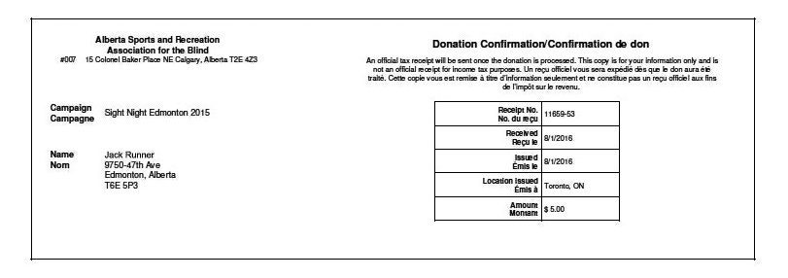

Official Tax Receipts: Tax receipts are issued by Running Room on behalf of the charity and include the charity logo and the charity officials name and signature. Donor receives 3 copies for income tax purposes.
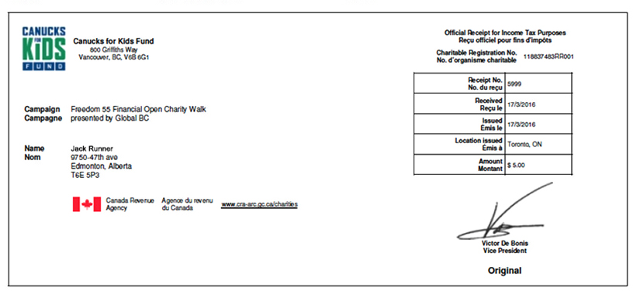
The following information is required to set-up Official Tax Receipts:
Official Charity Logo that displays on the left corner of the Tax Receipt.
Charities Officials name and a scan of their signature.
Please ensure that the scan of the signature is of a suitable contrast and resolution of at least 200dpi.
A block of receipt numbers that must adhere to the following rules:
- Receipt numbers can never begin with a zero
- Can have one hyphen (-)
- Can use letters, but not after a hyphen
- No spaces
- Number portion of the Max receipt number must be greater than the number portion of the Min receipt number
Examples of acceptable Tax Receipt sets:
• 1 to 500
• 85920001 to 85921000
• RR1 to RR500
• RR-1 to RR-500
• 2013-1 to 2013-1000
• RUN13-1 to RUN13-500
Note: Once the Tax receipts number sequence is selected it cannot be altered.

