We have updated the bib number assignment tools available for race directors using our on-line tools. You can now sign bib numbers by the ordering of last name, first name or registration date. Assignment alphabetically is preferred by many Race Directors in the preparation of race packages for pickup. RD's prefer the bib number to be in the same order as the alpha list which makes it easier for package pickup.
We have also corrected the error where the bib number's were always overwritten even though we stated they wouldn't be. We've now also made this a user configuration option via a check-box.
Procedure:
1. Log in as RD and go to your 'Import/Export' link. Here you will see the 'Race Numbers' link for bib # assignment tools. Determine how you want to assign the bib numbers and the starting sequence.
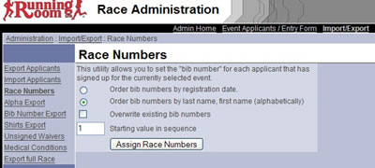
2. You can view each participants bib # assignment in a few ways. Firstly the participant applicants profile will display the assigned bib number as seen below - Bib Number 45.
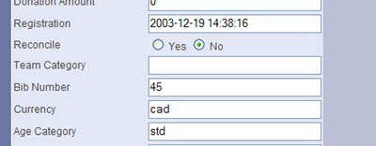
3. In addition you can do a 'Bib Number Export' from the same page where you assign the numbers. This will allow you to print off a quick list of all participants and the assigned bib numbers.
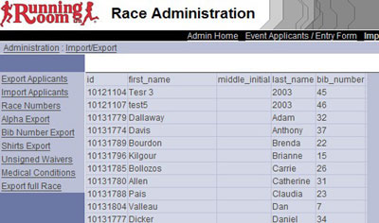
4. Participants can see their assigned bib # using the 'Confirmation List' which is viewed directly on the race registration site.
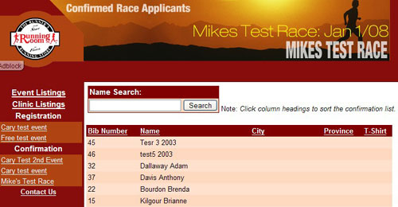

New Timing Company and RD Features
These changes allow for a much better experience using the system. A couple really nice features suggested by timing companies and now in place.
1. ability to assign bib numbers at the manual entry input stage by the RD,
2. ability to change the persons bib # using the transfer tool when you move an applicant from one event to another.
3. These two features work very well with the existing race number assignment tools that permits you to pre-assign bib #'s and print Bib # labels.
